
Tribhuvan University
Institute of Science and Technology
St. Lawrence College

Final Year Project Report on
“TrueTenant: Tenant Screening and Rental Risk Analysis System”
Submitted To:
Department of Computer Science and Information Technology
St. Lawrence College
Under the supervision of
Mr. Santosh Neupane
In partial fulfillment of the requirement for the Bachelor of Science in
Computer Science and Information Technology

Submitted by:
Reshi Shrestha [Symbol No.:79010536]
Mamata Subedi [Symbol No.:79010528]
Anil Giri [Symbol No.: 79010518]
BSc. CSIT 079 Batch, 7th Semester

July, 2026


Tribhuvan University
Faculty of Computer Science and Information Technology
St. Lawrence College

SUPERVISOR’S RECOMMENDATION

I hereby recommend that the project entitled “TrueTenant,” prepared under my supervision by Reshi Shrestha, Mamata Subedi, and Anil Giri, be submitted for evaluation in partial fulfillment of the requirements for the B.Sc. degree in Computer Science and Information Technology.

Mr. Santosh Neupane
Project Supervisor
Department of Computer Science
St. Lawrence College


Tribhuvan University
Faculty of Computer Science and Information Technology
St. Lawrence College

LETTER OF APPROVAL

This is to certify that this project prepared by Reshi Shrestha, Mamata Subedi, and Anil Giri Entitled "TrueTenant" In partial fulfillment of the requirement for the B.Sc. in Computer Science and Information Technology has been evaluated. In our opinion it is satisfactory in terms of scope and quality as a project for the required degree.
SIGNATURE of Supervisor  Mr. Santosh Neupane  St. Lawrence College,  Chuchhepati, Chabahil | SIGNATURE of HOD/ Coordinator  Mr. Apil Adhikari  St. Lawrence College,  Chuchhepati, Chabahil
SIGNATURE of Internal Examiner | SIGNATURE of External Examiner

ACKNOWLEDGEMENT
We would like to express our sincere gratitude to all those who supported and guided us throughout the development of this project. We are deeply thankful to our project supervisor for providing continuous guidance, valuable suggestions, and constant motivation that helped us complete this work successfully.
We are also grateful to the Department of CSIT, St. Lawrence College, for providing us with the necessary resources, infrastructure, and a conducive academic environment to carry out this project.
Special thanks are due to our colleagues and friends who offered constructive feedback and encouragement during various stages of the project. Their insights greatly contributed to the quality of this work.
Finally, we would like to thank our families for their unwavering support and patience throughout the course of this project. This work would not have been possible without the collective effort and encouragement of everyone involved.

Submitted By:
Reshi Shrestha [T.U. Registration No.:5-2-788-21-2022]
Mamata Subedi [T.U. Registration No.: 5-2-788-12-2022]
Anil Giri [T.U. Registration No.: 5-2-788-3-2022]

ABSTRACT
The Tenant Screening and Rental Risk Analysis System is a web-based application designed to automate and improve the tenant evaluation process for landlords and property managers. The system addresses the limitations of traditional, manual screening methods that are time-consuming, error-prone, and ineffective in predicting tenant default risks.
The platform uses a multi-technology stack, with HTML, CSS, and JavaScript for the frontend interface; PHP for backend logic and server-side processing; MySQL for relational data storage; and Python with Scikit-learn for machine learning based risk prediction. It includes two main analytical components: a weighted Risk Scoring Algorithm that assesses tenants based on credit score, employment status, references, and income ratio, and a Logistic Regression model that estimates the likelihood of rental default.
Key features include a tenant registration and document submission portal, a landlord dashboard for viewing applications and risk reports, automated risk categorization (Low, Medium, High), Realtime default probability predictions, and secure role-based access control with JWT based authentication. The system aims to reduce manual screening time, minimize financial losses due to rent defaults, and promote transparent and fair decision making in Nepal's growing rental housing market.
The Logistic Regression model was evaluated using a dataset of 500 tenant records and achieved an overall prediction accuracy of 86.00%. The experimental results demonstrate that the proposed hybrid approach effectively supports landlords in assessing tenant rental risk while maintaining transparency through the combination of rule-based scoring and machine learning prediction.

Keywords: Tenant Screening, Rental Risk Analysis, Logistic Regression, Risk Scoring, Web Based System, Machine Learning, Rental Default Prediction

TABLE OF CONTENTS
SUPERVISOR’S RECOMMENDATION i
LETTER OF APPROVAL ii
ACKNOWLEDGEMENT iii
ABSTRACT iv
TABLE OF CONTENTS v
LIST OF FIGURES vii
LIST OF TABLES viii
LIST OF ABBREVIATIONS ix
Chapter 1: Introduction 1
1.1 Introduction 1
1.2 Problem Statement 2
1.3 Objectives 3
1.4 Scope and Limitation 3
1.4.1 Scope 3
1.4.2 Limitations 4
1.5 Development Methodology 4
1.6 Report Organization 6
Chapter 2: Background Study and Literature Review 7
2.1 Background Study 7
2.2 Literature Review 8
Chapter 3: System Analysis 1
3.1 System Analysis 11
3.1.1 Requirement Analysis 11
3.1.2 Feasibility Analysis 14
Chapter 4: System Design 17
4.1 Design 17
4.1.1 Flowchart 17
4.1.2 Sequence Diagram 21
4.1.3 Activity Diagram 22
4.1.4 Database Schema 23
4.2 Algorithm Details 24
4.2.1 Algorithm 1: Risk Scoring Algorithm (Weighted Score Method) 24
4.2.2 Algorithm 2: Logistic Regression (Rental Default Prediction) 25
4.2.3 Hybrid Integration and Final Risk Score 26
4.2.4 Applicability of the Algorithms in TrueTenant 26
Chapter 5: Implementation and Testing 29
5.1 Dataset Description 29
5.2 Implementation 30
5.2.1 Tools and Technologies Used 30
5.2.2 Modules 31
5.3 Testing 32
5.4 Result Analysis 36
Chapter 6: Conclusion And Future Recommendations 38
6.1 Conclusion 38
6.2 Future Recommendations 38
References 40
Appendices 41

LIST OF FIGURES
Figure 1.1: Incremental Model 5
Figure 3.1: Use Case Diagram of TrueTenant 13
Figure 3.2: System Development Gantt Chart 16
Figure 4.1: Tenant Flowchart 18
Figure 4.2: Landlord Flowchart 19
Figure 4.3: Admin Flowchart 20
Figure 4.4: Sequence Diagram 21
Figure 4.5: Activity Diagram 22
Figure 4.6: Database Schema 23

LIST OF TABLES
Table 4.1: Sample Data 27
Table 5.1: Input Features Used for Prediction 29
Table 5.2: Authentication and Registration 32
Table 5.3: Application Submission 33
Table 5.4: Property Management 34
Table 5.5: Risk Score Engine 34
Table 5.6: Performance Evaluation of logistic Regression Model 36

LIST OF ABBREVIATIONS

AI | Artificial Intelligence
API | Application Programming Interface
CSS | Cascading Style Sheets
CRUD | Create, Read, Update, Delete
HTML | HyperText Markup Language
JS | JavaScript
ML | Machine Learning
MERN | MongoDB, Express.js, React.js, Node.js
MySQL | My Structured Query Language
PHP | Hypertext Preprocessor
SDLC | Software Development Life Cycle
SQL | Structured Query Language
UI | User Interface
UX | User Experience

Chapter 1: Introduction

Introduction
The rental housing sector plays a vital role in supporting urban economies by providing housing solutions for students, workers, and families. As cities grow rapidly, particularly in developing countries like Nepal, the demand for rental properties has increased significantly. With this growth, landlords and property managers face a persistent and complex challenge: evaluating potential tenants and predicting the risk of unpaid rent or property misuse. Traditional screening practices rely heavily on manual processes such as checking paper-based references, reviewing credit reports, and conducting phone interviews. These methods are not only time-consuming and costly but are also prone to clerical errors and subjective judgment, often failing to provide a reliable prediction of future tenant behavior or default risk. The growing need for digital solutions has opened an opportunity for smarter, automated systems that can assist in making more accurate and fair screening decisions.
The Tenant Screening and Rental Risk Analysis System is a web-based application designed to automate and streamline the tenant screening process. The system integrates multiple technologies: a frontend built with HTML, CSS, and JavaScript for an intuitive user interface; a backend developed using PHP to handle business logic, form processing, session management, database operations and a Python based machine learning module implementing logistic regression for rental default probability prediction.
The system provides a structured platform where tenants can register and submit their personal, financial, and employment details digitally. Landlords are equipped with a comprehensive dashboard to review applications, access automated risk scores, and view default probability predictions. By combining a rule based weighted scoring algorithm with a predictive machine learning model, the system delivers both transparency and accuracy in tenant evaluation. This project is particularly relevant in the context of Nepal, where rental disputes and missed payments have become increasingly common in urban areas.

Problem Statement
Tenant screening in Nepal and many other developing regions still depends heavily on outdated manual practices. Landlords often rely on paper-based references, informal phone verifications, and personal judgment instead of structured, data-driven assessment. Research on digital tenant risk-profiling tools shows that some automated systems operate as opaque scoring mechanisms, with landlords adopting risk scores without fully understanding how they are generated. This raises concerns about consistency, fairness, and transparency in screening decisions [1]. In contrast, modern AI-driven platforms show that tenant risk can be assessed more systematically by using machine learning models to evaluate credit history, income, and behavioral data [2]. This reveals a clear gap between the capabilities of automated screening and the practices commonly used in developing rental markets.
Financial loss is one of the most serious outcomes of ineffective tenant screening. Studies on machine learning models for default prediction indicate that ensemble methods such as Random Forest and Boost can identify high-risk applicants more accurately than traditional statistical approaches [3]. Related research on explainable loan-default prediction highlights income level, debt-to-income ratio, and credit grade as key indicators of default risk, emphasizing the need for models that are both accurate and interpretable [4]. Without predictive tools, landlords must depend on intuition, and financial damage is often discovered only after rent default, or property misuse has occurred.
Most rental management systems used in developing regions lacks these analytical capabilities. Industry-level screening platforms demonstrate that machine learning, predictive analytics, and natural language processing can process large volumes of applications quickly and consistently [5]. Benchmarking studies also show that algorithms such as XGBoost, neural networks, and logistic regression can deliver stronger predictive performance than single-method approaches [6]. However, such techniques are mostly limited to formal credit-scoring institutions, where statistical modeling and weighted evaluation criteria were developed for lending rather than informal rental markets [7]. As a result, many landlords in emerging rental markets still lack access to reliable analytical screening tools.

The absence of structured analysis also increases transparency and fraud-related risks. Rental application fraud guides report that applicants may use fabricated income documents, forged employment letters, or false rental histories to mislead landlords, especially when no systematic verification process exists [8]. In addition, studies on how landlords interpret tenant screening reports show a risk of automation bias, where landlords rely too heavily on risk scores without examining the underlying data. Applicants may also receive little or no explanation when their applications are rejected [9]. This lack of transparency can reduce trust and may contribute to inconsistent or discriminatory screening practices.
Therefore, there is a clear need for an intelligent, automated, and data-driven tenant screening system. Such a system should analyze key tenant-related factors, including income, employment status, rental history, and references, while combining rule-based transparency with predictive machine learning accuracy. This approach can support explainable, fair, and reliable risk assessment, helping landlords make more informed rental decisions.

Objectives
The primary objectives of this project are:
- To develop a web-based tenant screening platform with secure tenant registration and a landlord dashboard for viewing applications and risk reports with high accuracy.
- To design a hybrid risk assessment model combining weighted scoring with a Python logistic regression algorithm for default prediction, validated through feasibility testing.

Scope and Limitation

Scope
- Web-Based Tenant Registration: The system provides tenants with a self-service portal to register, upload documents, and submit rental applications online.
- Landlord Dashboard: A comprehensive interface for landlords to view, manage, and evaluate tenant applications with automated screening results.
- Risk Scoring Algorithm: A weighted scoring system evaluating rental history, employment status, references, and income ratio to classify tenants into risk categories.
- Machine Learning Integration: A logistic regression model implemented in Python that predicts the probability of rental payment default.
- Role-Based Access Control: Secure authentication and authorization mechanisms for tenants, landlords, and administrators.
- Database Management: A MySQL database to store and manage all user profiles, applications, documents, and risk reports.

Limitations
- Data Dependency: The accuracy of the logistic regression model depends heavily on the quality and size of the training dataset. Limited historical data may reduce prediction reliability.
- Cold Start Problem: New tenants with no rental history may not receive accurate risk scores, as the system lacks sufficient behavioral data for such users.
- Manual Knowledge Base: The system does not automatically learn from new interactions; the risk model requires periodic retraining with updated data.
- Unverified Scalability: While the system is designed to be scalable, it has not been stress-tested under high concurrent user loads or large-scale deployment conditions.
- No Mobile Application: The current implementation is limited to web browsers and does not include a dedicated mobile application.

Development Methodology
The project will be implemented using the Incremental Software Development Model. The model is appropriate for this project because the system will be built in increments where each increment is a fully tested and debugged component of the entire system. The project involves developing distinct modules. The incremental model is also suitable for this project because it allows reducing developmental risks associated with building an extremely complex system with hybrid risk analysis engine. Thus, the developmental process will involve multiple stages where each stage will result in an increment of the system. The developmental process will follow the following incremental steps which are divided into six key phases:
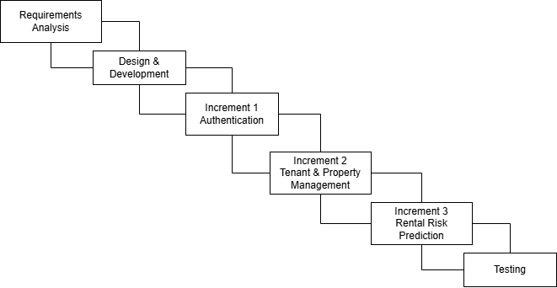
Figure 1.1: Incremental Model
- Requirement Analysis: This first stage will involve carrying out a detailed requirement analysis. During this stage, the three main system actors will be identified. They include the tenant, the landlord, and the admin. The technical, operational, economic, and schedule feasibility of the proposed system will be evaluated at this stage.
- Design and Development: This phase involves the actual design and coding of the system. The system is built increment by increment, starting with the tenant module, followed by the landlord, the risk scoring engine, the machine learning module, and finally the admin module. Each increment is designed and developed before moving to the next.
- Testing: The developed components will be subjected to testing to ensure that they meet the design specifications. Testing starts with the testing of the individual developed modules. Once the individual modules have been tested, all the system components will be merged and tested as a single entity to ensure that they operate together with no compatibility issues.
- Implementation: The final step in the incremental development model will involve deploying the system to the target site for final testing and actual implementation. Here, the system will be configured into the target environment so that it can be used by the system users.
- Evaluation and Feedback: This process is very crucial because it enables various evaluation checks to be carried out. For instance, it allows a determination of the extent to which the system met the initial requirements. The evaluation will also involve determining the accuracy of the risk scores predicted by the machine learning models as well as assessing how useful the new technology was.
- Maintenance: The final process involved in the incremental development model will involve carrying out maintenance on the system. This step will involve troubleshooting errors and addressing other issues arising. Lastly, changes will also be made based on the feedback received from all the stakeholders.

Report Organization
This report is organized into the following chapters:
Chapter 1 (Introduction): Covers the background, problem statement, objectives, scope, limitations, development methodology, and report organization.
Chapter 2 (Background Study and Literature Review): Reviews existing rental management systems, tenant screening practices, and related work to identify gaps that this project addresses.
Chapter 3 (System Analysis): Presents the requirement analysis (functional and non-functional), feasibility study, and use case diagram.
Chapter 4 (System Design): Describes the system architecture, flowchart, algorithms, and high-level design of all components.
Chapter 5 (Implementation and Testing/ Result Analysis): Discusses the tools and technologies used, implementation details, testing results and presents an analysis of the outcomes generated by the system.
Chapter 6 (Conclusion and Future Recommendations): Summarizes the project outcomes and outlines future enhancement possibilities.

Chapter 2: Background Study and Literature Review

Background Study
The rental housing market plays a vital role in providing accommodation to individuals and families worldwide. Effective tenant screening is essential for landlords to minimize financial risks such as rental defaults, property damage, and lease violations. Traditionally, tenant screening relied on manual reviews of application documents, credit reports, references, and background checks. While these methods offer basic insights, they are time-consuming, prone to human bias, and often lack comprehensive risk prediction capabilities.
Research in this domain draws from established practices in credit scoring and risk assessment. Studies on machine learning algorithms for predicting probabilities of default demonstrate how models can analyze historical data to forecast tenant behavior with greater accuracy [3]. Comprehensive works on credit scoring highlight the application of statistical and computational techniques to evaluate borrower reliability, which directly translates to tenant risk evaluation. Furthermore, explainable machine learning approaches for loan default prediction provide frameworks for transparent risk scoring that landlords can trust and interpret.
Additional literature emphasizes the integration of diverse data sources in rental decisions. Algorithmic approaches to tenancy evaluation examine how ordinal tenant assessments influence outcomes, while studies on landlord preferences reveal which information in screening reports most impacts approval decisions. Detection of rental application fraud also emerges as a critical component, addressing deceptive practices that undermine traditional screening methods.
Despite these developments, several limitations persist in current tenant screening systems. Many platforms rely solely on either rule-based scoring or black-box machine learning models, leading to incomplete risk profiles. Purely automated systems may overlook nuanced contextual factors, while manual processes remain inefficient for high-volume property management. Integration of multiple evaluation methods is often lacking, resulting in fragmented insights for landlords. Moreover, the absence of unified web-based platforms that support end-to-end management for tenants, landlords, and administrators restricts accessibility and overall efficiency.
To address these challenges, the proposed Tenant Screening and Rental Risk Analysis System offers a comprehensive web-based solution for rental property management. Tenants can register, build detailed profiles, upload supporting documents, browse properties, set preferences, and submit applications seamlessly. Landlords gain tools to list and manage properties, review applications, and make informed approval or rejection decisions. An administrative module enables system oversight, user management, and statistical reporting.
The core innovation lies in its hybrid risk assessment approach. A PHP-based weighted scoring system evaluates key factors such as income, employment status, references, and rental history. This is complemented by a Python machine learning model that predicts tenant risk probability. The two outputs are combined into a final risk score, allowing applications to be sorted with higher-risk cases prioritized for review. Built using PHP for the backend, MySQL for data storage, HTML/CSS/JavaScript for the frontend, and Python for advanced predictions, the system aims to empower landlords with data-driven decision-making while maintaining transparency and usability.
Through this integrated platform, the project seeks to modernize tenant screening, reduce risks for property owners, and create a more efficient rental ecosystem.

Literature Review
Tenant screening and rental risk assessment have been studied from multiple angles by different researchers and industry practitioners, ranging from purely commercial screening platforms to academic studies on algorithmic fairness and credit risk prediction. This section reviews these existing works to understand what has already been done, what methods have proven effective, and what gaps remain that this project aims to address.
One of the earliest shifts in tenant screening came from the introduction of automated screening platforms that moved away from purely manual evaluation. These platforms process rental applications using machine learning, predictive analytics, and automated data workflows rather than relying entirely on a landlord's personal judgment [5]. Related commercial platforms have taken a similar approach, using applicant credit history, income data, and behavioral indicators to build a structured risk profile for each tenant rather than depending on subjective phone interviews [2].
While traditional statistical methods such as logistic regression remain popular because of their simplicity and interpretability, more recent research has explored whether machine learning algorithms can outperform these traditional models. A comparative study evaluating several machine learning algorithms for predicting the probability of loan default tested Random Forest, Decision Trees, XGBoost, Gradient Boosting, and AdaBoost against standard logistic regression. The results showed that ensemble-based methods, particularly Random Forest and XGBoost, consistently achieved higher recall, precision, F1 score, and area under the curve compared to logistic regression, which performed considerably worse across most metrics in that particular study [4]. A separate but related study focused specifically on credit card customers compared six algorithms, including neural networks, logistic regression, AdaBoost, XGBoost, and LightGBM, and found that XGBoost achieved the highest overall accuracy at 99.4 percent [6]. Both studies reach a similar conclusion, that ensemble machine learning methods tend to outperform single statistical models such as logistic regression when predicting financial default risk. This is an important consideration for this project, since it confirms that machine learning based prediction can add real value beyond a purely rule-based scoring system, even though logistic regression was ultimately selected here due to its relative simplicity and feasibility for a smaller scale academic project.
Closely related to the discussion of predictive accuracy is the growing research interest in explainability. A study on explainable loan default prediction specifically examined which applicant features most strongly influence a model's prediction, identifying income level, debt to income ratio, and credit grade as the most significant indicators of default risk. The researchers emphasized that predictive models intended for real world financial decisions should not only be accurate but also interpretable, so that both institutions and applicants can understand why a particular prediction was made [4]
Beyond prediction accuracy and transparency, fraud remains a persistent and separate challenge within tenant screening. A practical guide focused specifically on rental application fraud detection outlines how applicants may submit fabricated income documents, forged employment letters, or falsified rental histories in an attempt to improve their chances of approval. According to this source, when no systematic verification process exists, such fraudulent information frequently goes undetected during manual screening, which can eventually lead to significant financial losses and legal disputes for landlords [8]. This finding highlights a gap that purely predictive or purely rule-based systems may not fully address on their own, and it supports the inclusion of structured document verification and multiple layers of evaluation in the system developed for this project.
Taken together, the reviewed studies and platforms reveal a clear pattern. Automated tenant screening systems and machine learning based credit risk models have each been studied extensively, and both consistently demonstrate improvements in speed, consistency, and predictive accuracy compared to fully manual approaches. At the same time, research on algorithmic fairness and landlord behavior reveals that automation without transparency can introduce new problems, including automation bias and reduced applicant trust [1]. Traditional credit scoring theory offers a proven, interpretable foundation for weighted risk evaluation [7], while newer research on explainable prediction models argues that even advanced machine learning systems must remain interpretable to be genuinely useful in real world decision-making [4]. Fraud detection research further shows that predictive accuracy alone is not sufficient, since verification of submitted information remains equally important [8].
What becomes clear from this body of research is that very few existing systems combine all of these elements together. The number of months late payment, monthly rent, and the tenant’s individual characteristics, that is, the expense-to-income ratio, gender, and age, were the main factors affecting the credit score. The proposed credit scoring will increase the confidence of future property owners and developers to select the low-income group [10]. There remains limited work that specifically combines a transparent, rule-based weighted scoring method with a machine learning prediction model within a single, unified rental risk assessment system, particularly one designed for a developing rental market such as Nepal, where formal credit scoring infrastructure is limited and manual screening still dominates. This gap forms the direct motivation for the Tenant Screening and Rental Risk Analysis System developed in this project, which aims to bring together the interpretability of traditional weighted scoring, the predictive power of machine learning, and safeguards against fraudulent applicant information within a single, cohesive platform.

Chapter 3: System Analysis

System Analysis
System analysis is the process of studying and defining the requirements of a system to ensure that the developed solution meets user needs and solves the identified problems. For the Tenant Screening and Rental Risk Analysis System, the analysis phase involved studying existing rental management practices, interviewing potential users (landlords and tenants), and reviewing relevant literature to identify functional and non-functional requirements.

Requirement Analysis
The requirements for the system can be termed as functional and non-functional requirements.
Functional Requirements
- User Account Management: The system shall allow tenants and landlords to register, log in, and manage their profiles securely. It should also provide a password recovery mechanism in case users forget their login credentials. All account data shall be stored and handled securely to protect user privacy.
- Tenant Profile and Documentation: Tenants shall be able to upload personal documents, employment details, and rental history for verification purposes. This information shall be stored and linked to the tenant's profile for use during the screening process. The uploaded documents shall support both the weighted scoring engine and the machine learning prediction module.
- Landlord Dashboard: The system shall provide landlords with a dashboard to manage property listings and view submitted tenant applications. Landlords shall be able to access generated screening and risk reports directly from this dashboard. The dashboard shall support quick decision-making by presenting applications sorted by risk level.
- Tenant Screening Module: The system shall verify tenant information and evaluate financial stability based on predefined screening criteria. It should analyze rental behavior using data such as income, employment status, and rental history. This module serves as the primary data source for both risk scoring and machine learning components.
- Risk Scoring System: The system shall generate an automated, rule-based risk score using weighted criteria such as income level, payment history, employment status, and past rental records. Each factor contribute proportionally to the final score based on its assigned weight. The score generated shall be transparent and traceable to its contributing factors.
- Machine Learning Module: The system shall use a logistic regression algorithm to predict the probability of rent default for each tenant. Based on this prediction, tenants shall be classified into Low, Medium, or High-risk categories. This prediction shall be combined with the weighted score to produce the final overall risk assessment.
- Reporting and Notification System: The system shall generate screening reports and risk analysis summaries for each tenant application. It shall automatically send notifications to landlords and tenants once an application has been reviewed. These notifications should keep both parties informed of application status and outcomes in real time.

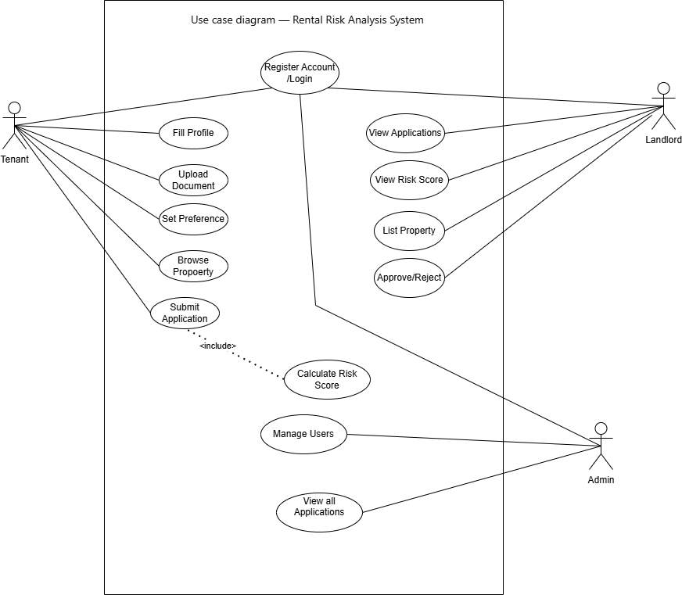
Figure 3.1: Use Case Diagram of TrueTenant
The use case diagram was created to depict the relationship between users and the TrueTenant System. The Tenant can register or log in to the system, edit his/her profile, upload required documents, set rental preferences, search for properties, and apply for a rental. Once an application is submitted, the calculate risk score feature will be automatically engaged to assess a tenant’s information and provide the landlord with a risk score based on the input data. Hence, the Landlord can log in to the system, check the list of applicants, review an automatically calculated risk score, post available properties, approve or reject applications.
The admin can manage the users and monitor all the applications available in the system making sure that everything operates smoothly and securely. In general, the use case diagram above shows the main characteristics of the Tenant Screening and Rental Risk Analysis System, which is a comprehensive rental screening platform for tenants, landlords, and admins.
Non-Functional Requirements
- Performance:
The system shall complete login, dashboard loading, and risk score generation within 2–3 seconds under normal local network/server conditions.
- Usability:
The system shall provide a simple, role-based interface (Tenant, Landlord, Admin) with clear navigation, readable forms, and color-coded risk labels (Low/Medium/High).
- Reliability:
The system shall return consistent risk results for identical tenant input values when using the same rule weights and trained ML model.
- Scalability:
The system shall support increasing numbers of users, properties, and applications, and allow future extension (API/mobile integration) without major redesign of core modules.
- Security:
The system shall enforce authenticated access, role-based authorization, prepared SQL statements, and secure password hashing for stored credentials.
- Maintainability:
The system should keep business logic, database operations, and ML prediction logic modular so that model files can be retrained/replaced without changing UI workflows.

Feasibility Analysis
A feasibility study is an extensive review and evaluation of a proposed project's probability of success and profitability. It investigates a number of factors, including technical, operational, financial, legal, regulatory, and environmental possibilities. The assessment aims to determine the project's feasibility under specific constraints, taking into account factors such as technical readiness, resource availability, and cost compliance.
- Technical Feasibility
The availability and suitability of the instruments, technologies, and technical resources needed for system development are assessed by technical feasibility. The suggested system would make use of well-known and open-source technologies such as PHP for backend processing, MySQL for database administration, HTML, CSS, and JavaScript for frontend development, and Python for implementing machine learning models. Using well-known tools like Scikit-learn and NumPy, we will examine machine learning techniques like logistic regression. These technologies offer dependable assistance with predictive modelling and data processing.
- Operational Feasibility
Operational feasibility evaluates whether the proposed system can be effectively used within the existing rental management environment. The system is designed to be user-friendly, with simple navigation and clear interfaces for both tenants and landlords. This reduces the need for extensive training. The automated tenant screening and risk analysis features will significantly reduce manual workload and administrative effort. Landlords will be able to access screening reports and risk scores instantly, while tenants can submit applications and documents online. The system will integrate smoothly with current rental practices and does not require major changes in operational procedures. Automated notifications, report generation, and digital record keeping will further enhance efficiency. Hence, the system is operationally feasible.
- Economic Feasibility
Economic feasibility assesses the financial viability of the project. The development cost of the system is relatively low, as most of the tools and frameworks used in the project are open-source and freely available. This reduces expenses related to software licensing. Hardware requirements are minimal, and the system can be hosted on affordable cloud or shared hosting platforms. Maintenance and update costs are also low due to the modular design of the system. By reducing rent defaults, minimizing disputes, and improving management efficiency, the system is expected to provide significant financial benefits to landlords. These benefits outweigh the development and maintenance costs, making the project economically feasible.
- Schedule Feasibility
To ensure systematic progress and timely completion, the project will follow a structured development schedule. The entire development process is planned to be completed within three months.
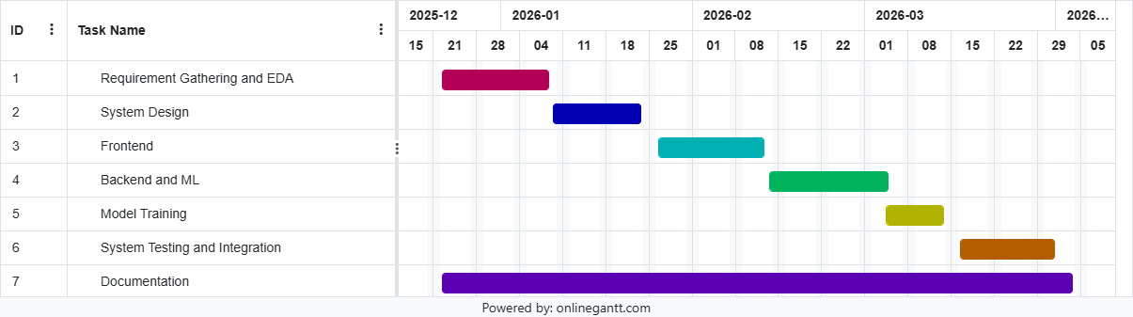
Figure 3.2: System Development Gantt Chart

Chapter 4: System Design

Design
System design is the process of planning how the different components of a system will work together to achieve its purpose. It serves as a blueprint that defines the system’s overall structure, data flow, and interactions between users, the front end, backend, and database. Through system design, developers decide how each part will communicate, what technologies will be used, and how the system will handle processes efficiently and securely. In short, it provides a clear roadmap for building a well-structured, functional, and reliable software system.

Flowchart
The flow charts illustrate the overall workflow of the proposed Tennant System. They describe how the three primary users: Tenant, Landlord, and Administrator, interact with the system.
The tenant begins by registering an account and logging into the system. After completing their profile and uploading the required documents, they set their rental preferences and browse available properties. If they find a suitable property, they submit a rental application; otherwise, they continue browsing until they find an appropriate listing.
The landlord registers or logs into the system, lists rental properties, and accesses the dashboard to review tenant applications. Based on the machine learning-generated risk score, the landlord decides whether to approve (low risk), mark the application under review (medium risk), or reject (high risk). The selected status is then updated in the system.
The administrator logs into the system and accesses the admin dashboard. From there, the administrator can manage tenant and landlord accounts, monitor and update user information, view all rental applications and properties, and track the average risk scores generated by the system. After completing a task, the administrator may continue performing additional actions or log out of the system.

- Tenant Flowchart
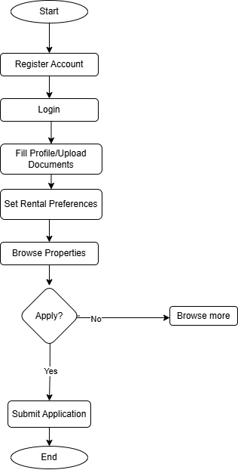
Figure 4.1: Tenant Flowchart

- Landlord Flowchart

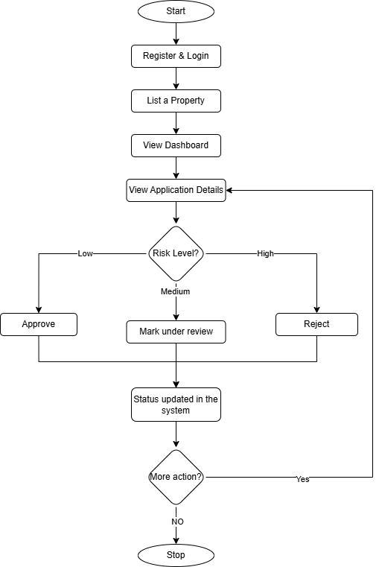
Figure 4.2: Landlord Flowchart

- Admin Flowchart

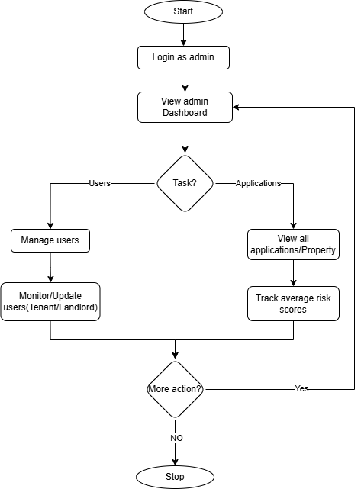
Figure 4.3: Admin Flowchart

Sequence Diagram

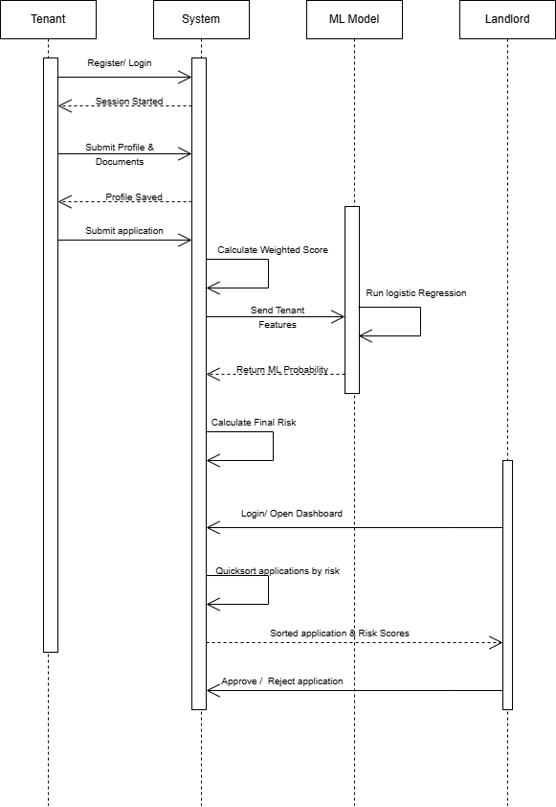
Figure 4.4: Sequence Diagram

Activity Diagram
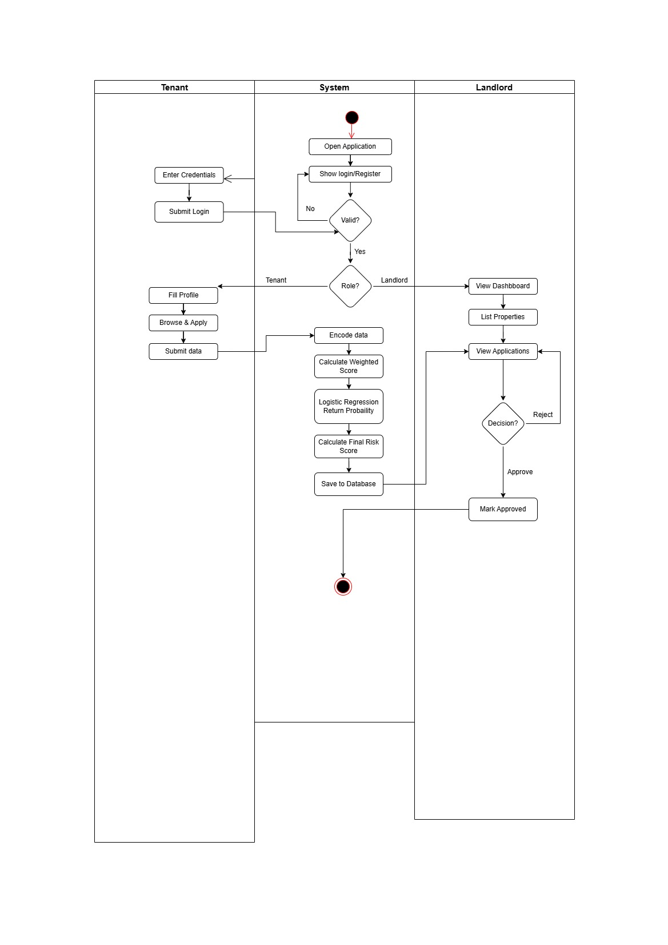
Figure 4.5: Activity Diagram

Database Schema
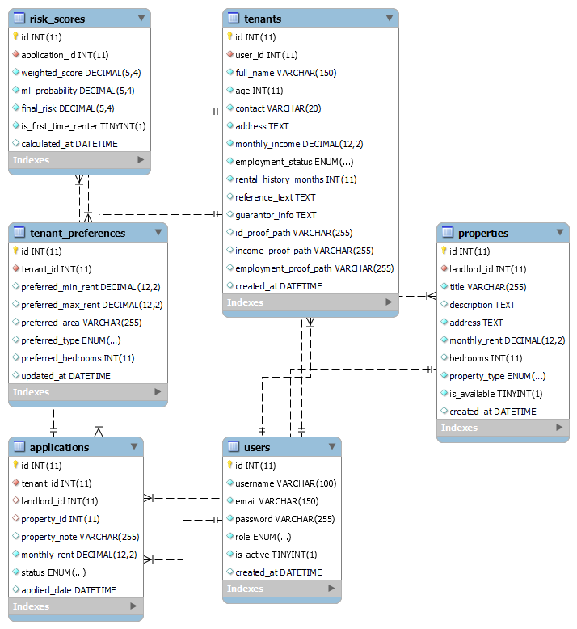
Figure 4.6: Database Schema

Algorithm Details
The TrueTenant system employs a hybrid risk assessment approach consisting of a rule-based weighted scoring algorithm and a supervised machine learning model based on Logistic Regression. The weighted scoring method provides transparency by assigning predefined weights to important tenant attributes, while Logistic Regression predicts the probability of rental default using historical tenant data. The outputs of both components are combined to generate a final risk assessment that assists landlords in making informed and data-driven rental decisions.

Algorithm 1: Risk Scoring Algorithm (Weighted Score Method)
The Risk Scoring Algorithm is a rule-based evaluation technique used to assess the suitability of a tenant by assigning predefined weights to important screening criteria. In rental housing, landlords typically consider multiple factors before approving an applicant, including employment stability, income level, creditworthiness, rental history, and references. However, manual assessment of these factors is often subjective and inconsistent. To address this issue, the TrueTenant system implements a weighted scoring approach that systematically evaluates tenant information and converts it into a numerical score representing the overall level of rental risk.
The weighted scoring method is widely used in decision-support systems because of its simplicity, transparency, and interpretability. Each screening criterion is assigned a percentage weight based on its relative importance in the tenant selection process. For example, credit score contributes significantly to determining financial reliability, while employment status and income ratio provide insights into a tenant's ability to meet rental obligations consistently. References supplied by previous landlords or employers further strengthen the assessment by providing additional evidence of tenant behavior. By combining these factors, the algorithm produces a score ranging from 0 to 1, where higher scores indicate higher rental risk.
The final score is calculated using the following equation:
Risk Score: (0.4 × income) + (0.3 × Employment) + (0.2 × References) + (0.1 × history)
Based on the resulting value, tenants are categorized into Low, Medium, or High Risk groups. This approach provides landlords with an explainable assessment mechanism, allowing them to understand how each factor contributes to the final score while ensuring consistency across all tenant evaluations.
The selection of tenant evaluation factors in the TrueTenant system was informed by existing studies on tenant credit scoring and rental risk assessment. Previous studies on tenant credit scoring have identified late payment history, expense-to-income ratio, previous monthly rent, and tenant characteristics as significant factors affecting tenant creditworthiness [10]. The findings demonstrated that financial indicators and tenant characteristics play a significant role in determining rental reliability and predicting default behavior. Building upon these findings, the TrueTenant system adopts a simplified set of screening criteria consisting of Employment Status, Income Ratio, Rental History and References.

Algorithm 2: Logistic Regression (Rental Default Prediction)
Logistic Regression is a supervised machine learning algorithm commonly used for binary classification problems. It is particularly suitable for predicting outcomes that have two possible classes, such as default or non-default. In the context of the TrueTenant system, Logistic Regression is employed to estimate the probability that a tenant may fail to meet future rental obligations based on historical rental and financial information. Unlike traditional rule-based methods, the algorithm identifies patterns within historical data and uses these patterns to make probability-based predictions for new tenant applications.
The model utilizes several tenant attributes as input features, including income level, employment status, rental history and references. During training, the algorithm learns the relationship between these features and previous rental outcomes, enabling it to estimate the likelihood of rent default. The output of the model is a probability value ranging from 0 to 1, where values closer to 1 indicate a higher probability of default. This probability is subsequently mapped to predefined risk categories to assist landlords during the decision-making process.
Logistic Regression is mathematically represented by the sigmoid function:
P(Default) = 1 / (1 + e⁻ᶻ)
where: z = b₀ + b₁x₁ + b₂x₂ + ... + bₙxₙ
Here, b₀ denotes the intercept term, b₁...bₙ represent the learned model coefficients, and x₁...xₙ correspond to the input features. Logistic Regression was selected for this project due to its computational efficiency, interpretability, and suitability for smaller datasets. Additionally, its ability to produce probability-based predictions makes it particularly useful for rental risk assessment applications, where understanding the likelihood of default is more valuable than obtaining a simple binary outcome.

Hybrid Integration and Final Risk Score
The TrueTenant system adopts a hybrid risk assessment approach by integrating the outputs of the weighted Risk Scoring Algorithm and the Logistic Regression model. Individually, each algorithm provides valuable insights into tenant suitability; however, combining both methods allows the system to leverage the strengths of each approach. The weighted scoring algorithm offers transparency and explainability, while Logistic Regression contributes predictive capabilities by identifying relationships present in historical rental data. This integration results in a more comprehensive and reliable assessment of tenant risk.
The hybrid model is designed to balance rule-based evaluation with machine learning predictions. First, the weighted scoring algorithm calculates a tenant's score using predefined screening criteria. Next, the Logistic Regression model estimates the probability of rental default. The outputs are then combined to produce a final risk score that reflects both current tenant characteristics and historical behavioral patterns. This combined approach reduces dependence on subjective judgment and improves consistency in tenant screening decisions.
The final risk score is computed using the following equation:
Final Risk Score = (Risk Score × 0.6) + (( P(Default) × 0.4)
where Risk Score represents the output of the weighted scoring algorithm and P(Default) represents the probability generated by the Logistic Regression model. Based on the final score, tenants are categorized into Low, Medium, or High Risk groups. The hybrid approach enhances the overall effectiveness of the TrueTenant system by combining interpretability and predictive accuracy, ultimately enabling landlords to make more informed, data-driven rental decisions.

Applicability of the Algorithms in TrueTenant
To illustrate how the algorithms work together in practice, consider the following realistic scenario:
Scenario:
A landlord has received three tenant applications for the same property. The system processes them using the hybrid risk assessment and then sorts them using Quick Sort.
Sample Tenant Data:
Table 4.1: Sample Data
Tenant_id | Income Ratio | Employment Score | References Score | Rental History
T101 | 0.10 | 0.10 | 0.10 | 0.10
T102 | 0.60 | 0.60 | 0.40 | 0.50
T103 | 1.00 | 0.90 | 0.80 | 1.00

Step 1: Weighted Risk Scoring (Algorithm 1)
Formula:
S = (0.4 × income_ratio) + (0.3 × Employment) + (0.2 × References) + (0.1 × history)

T101: (0.4×0.10) + (0.3×0.10) + (0.2×0.10) + (0.1×0.10) = 0.10 → Low Risk
T102: (0.4×0.60) + (0.3×0.60) + (0.2×0.40) + (0.1×0.50) = 0.55 → Medium Risk
T103: (0.4×1.00) + (0.3×0.90) + (0.2×0.80) + (0.1×1.00) = 0.93 → High Risk

Step 2: Logistic Regression Prediction (Algorithm 2)
The ML model returns the probability of default:
T101 → 18% chance of default
T102 → 58% chance of default
T103 → 85% chance of default

Step 3: Final Risk Score Calculation
Formula:
Final Score = (0.6 × Weighted Score) + (0.4 × (1 - ML Probability))
T101: (0.6 × 0.10) + (0.4 × 0.18) = 0.14
T102: (0.6 × 0.55) + (0.4 × 0.58) = 0.56
T103: (0.6 × 0.93) + (0.4 × 0.85) = 0.91
Step 4: Sorting
The system now applies Quick Sort on the applications based on the Final Risk Score so the highest risk appears first.
Before Sorting (Random Order):
T103 (0.91) → T101 (0.14) → T102 (0.56)
After Quick Sort (Highest Risk First):
T103 – Final Score: 0.91 (High Risk) ← Reviewed First
T102 – Final Score: 0.56 (Medium Risk)
T101 – Final Score: 0.14 (Low Risk)
Result on Landlord Dashboard:
The landlord sees T103 at the top with red highlighting and a warning.
They can immediately focus on the riskiest application while still viewing the detailed breakdown of all scores.

Chapter 5: Implementation and Testing

Dataset Description
The dataset used for training the Rental Risk Prediction model is a structured CSV file containing tenant financial, demographic, and rental-background attributes.
The dataset contains 500 records with 7 variables, including 6 predictive features and 1 target label.
Preprocessing steps applied to the dataset:
- Rows with malformed or non-numeric values were skipped during data loading.
- Selected feature columns were used for model training:
monthly_income, employment_code, rental_history_months, has_reference, monthly_rent, and age.
- Categorical employment status was encoded numerically as:
1 = employed, 2 = self-employed, 3 = student, 4 = unemployed.
- Binary reference availability was encoded as:
0 = No, 1 = Yes.
- The dataset was split into training (80%) and testing (20%) sets using a fixed random state of 42 with stratified sampling.
- Feature scaling (standardization) was applied using StandardScaler before logistic regression training.
Table 5.1: Input Features Used for Prediction
Features | Type | Description
monthly_income | Numerical | Tenant monthly income
employment_code | Categorical | Employment category of tenant
rental_history_months | Numerical | Previous rental experience in months
has_reference | Binary | Whether tenant has reference information
monthly_rent | Numerical | Expected monthly rent for applied property
Age | Numeric | Tenant age

Implementation

Tools and Technologies Used
- HTML, CSS, and JavaScript (Frontend)
HTML provides the structural foundation for all web pages, CSS is used for styling and responsive layout design, and JavaScript handles client-side validation, dynamic content updates, and user interaction. Together, they provide a clean and intuitive interface for both tenants and landlords.
- PHP (Backend)
PHP serves as the server-side scripting language, handling business logic, user authentication, form processing, API creation, and the integration bridge between the web frontend and the Python ML module. PHP invokes Python scripts via command-line execution to obtain risk predictions.
- MySQL (Database)
MySQL is used as the relational database management system to store all platform data including user profiles (tenants and landlords), rental applications, uploaded documents, risk scores, and prediction results. The schema includes tables for Tenant, Landlord, Application, RiskScore, and Prediction.
- Python with Scikit-learn (Machine Learning)
Python is used to implement and run the logistic regression model for rental default prediction. The Scikit-learn library provides pre-built, efficient implementations of logistic regression, along with tools for data preprocessing, model training, and evaluation. NumPy and Pandas are used for numerical computation and data manipulation respectively.
- VS Code (Development Environment)
Visual Studio Code served as the primary development environment, providing features such as syntax highlighting, integrated terminal, Git support, debugging tools, and extensions for PHP, JavaScript, and Python development.
- GitHub (Version Control)
Git was used for version control and GitHub for hosting the project repository, supporting team collaboration, code tracking, and continuous integration throughout the development lifecycle.

Modules
Tenant Module
The Tenant Module allows tenants to register, log in, complete their profile, upload required documents, browse available rental properties, set rental preferences, and submit rental applications. It provides tenants with a simple digital platform to manage their rental application process.
Landlord Module
The Landlord Module allows landlords to register, log in, add and manage property listings, view tenant applications, and review automatically generated risk scores. This module helps landlords make faster and more informed approval or rejection decisions.
Admin Module
The Admin Module is used to manage and monitor the overall system. It allows the administrator to manage tenant and landlord accounts, check rental applications, view system statistics, and ensure that all system features work smoothly.
Risk Scoring Module
The Risk Scoring Module calculates a tenant’s risk level using weighted factors such as income, employment status, rental history, references, and affordability. It classifies tenants into low, medium, or high-risk categories to support landlord decision-making.
Machine Learning Prediction Module
The Machine Learning Prediction Module uses logistic regression to predict the probability of rental default. It analyzes tenant data and provides an additional data-driven prediction that improves the accuracy of tenant risk assessment.

Testing
Testing was conducted to verify that all system components function correctly, individually and in integration. Unit testing was performed on each module, followed by integration testing to ensure seamless communication between the frontend, backend, database, and ML components.
Table 5.2: Authentication and Registration
ID | Test Case Description | Input | Expected Output | Actual Output | Status
TC-01 | Login with valid credentials | Correct username and password | User is logged in and taken to their dashboard | User is logged in and taken to their dashboard | Pass
TC-02 | Login with invalid password | Correct username, wrong password | Error message: invalid username or password | Error message: invalid username or password | Pass
TC-03 | Login with deactivated account | Account that admin has deactivated | Error message: account has been deactivated | Error message: account has been deactivated | Pass
TC-04 | Register with mismatched passwords | Password and confirm-password fields don't match | Error message: passwords do not match | Error message: passwords do not match | Pass
TC-05 | Register with duplicate username/email | Username or email that already exists in the system | Error message: username or email already exists | Error message: username or email already exists | Pass
TC-06 | Register with a short password | A password shorter than 6 characters | Error message: password must be at least 6 characters | Error message: password must be at least 6 characters | Pass
TC-07 | Register as tenant (valid data) | New unique username/email, choose 'Tenant' | Account created, logged in automatically, sent to fill profile page | Account created, logged in automatically, sent to fill profile page | Pass
TC-08 | Register as landlord (valid data) | New unique username/email, choose 'Landlord' | Success message shown, user must log in manually | Success message shown, user must log in manually | Pass
TC-09 | Logout | Click the logout button while logged in | User is logged out and returned to the home page | User is logged out and returned to the home page | Pass

Table 5.3: Application Submission
ID | Test Case Description | Input | Expected Output | Actual Output | Status
TC-10 | Submit a rental application (normal case) | Tenant with a completed profile fills the form and submits | Application is saved and a risk score is generated automatically | Application is saved and a risk score is generated automatically | Pass
TC-11 | Submit application with no rent amount entered | Leave the rent field empty or enter 0 | Error message: invalid application data | Error message: invalid application data | Pass
TC-12 | Submit application before completing profile | Tenant who has not filled their profile tries to apply | Error message: please complete your profile first | Error message: please complete your profile first | Pass

Table 5.4: Property Management
ID | Test Case Description | Input | Expected Output | Actual Output | Status
TC-13 | Landlord adds a new property listing | Landlord fills in property name, address, and rent, then saves | Property is saved and appears in the landlord's property list | Property is saved and appears in the landlord's property list | Pass
TC-14 | Tenant browses available properties | Tenant opens the 'browse properties' page | List of available properties is shown | List of available properties is shown | Pass

Table 5.5: Risk Score Engine
ID | Test Case Description | Input | Expected Output | Actual Output | Status
TC-15 | Risk score for a strong tenant | Tenant earns 3x the rent, is employed, has a guarantor and reference, rented before for 2+ years | System marks them as Low Risk | System marks them as Low Risk | Pass
TC-16 | Risk score for a weak tenant | Tenant earns less than the rent, is unemployed, has no reference or guarantor, never rented before | System marks them as High Risk | System marks them as High Risk | Pass
TC-17 | Student tenant who has a guarantor | Tenant is a student, but has a guarantor listed | Treated as a lower risk than a student with no guarantor | Treated as a lower risk than a student with no guarantor | Pass
TC-18 | Student tenant with no guarantor | Tenant is a student, no guarantor listed | Treated as a higher risk than a student with a guarantor | Treated as a higher risk than a student with a guarantor | Pass

All unit tests passed successfully. Integration testing confirmed that the frontend, PHP backend, MySQL database, and Python ML module communicate seamlessly. System testing verified that all major features, tenant registration, risk scoring and landlord dashboard, work cohesively under realistic conditions.

Result Analysis
The proposed Tenant Screening and Rental Risk Analysis System was evaluated using both functional testing and machine learning performance evaluation. Functional testing verified that all major modules, including user authentication, tenant management, property management, rental risk prediction, and report generation, operated successfully according to the specified system requirements.
To evaluate the prediction model, a Logistic Regression classifier was trained using a synthetic demonstration dataset consisting of 500 tenant records, of which 196 represented high-risk (defaulted) tenants and 304 represented low-risk (non-defaulted) tenants. The dataset was divided into training and testing sets using an 80:20 ratio, resulting in 100 records being used for testing.
Table 5.6: Performance Evaluation of logistic Regression Model
Evaluation Metric | Value
Accuracy | 86.00%
Precision (Low Risk) | 89%
Recall (Low Risk) | 89%
F1-Score (Low Risk) | 89%
Precision (High Risk) | 82%
Recall (High Risk) | 82%
F1-Score (High Risk) | 82%

The experimental results demonstrate that the Logistic Regression model achieved an overall accuracy of 86.00%, indicating that the model correctly classified 86 out of every 100 tenant applications in the testing dataset. The model achieved a precision, recall, and F1-score of 89% for the low-risk class and 82% for the high-risk class. These results indicate that the model effectively distinguishes between tenants who are likely to default and those who are expected to meet their rental obligations.
The slightly lower performance for the high-risk class suggests that predicting rental default is more challenging than identifying reliable tenants. However, the overall evaluation demonstrates that the proposed model provides a reliable basis for supporting landlord decision-making during the tenant screening process.
Unlike conventional rule-based systems, the proposed application integrates a weighted rule-based risk score with the Logistic Regression probability prediction. The rule-based component evaluates important screening criteria such as payment history, income stability, employment status, and supporting factors, while the Logistic Regression model identifies statistical patterns learned from historical data. The combination of these two approaches improves both prediction transparency and decision support.
It should be noted that the evaluation was performed using a synthetically generated demonstration dataset developed for academic purposes. Therefore, although the obtained results validate the functionality and predictive capability of the proposed system, future work should focus on evaluating the model using larger real-world rental datasets to further improve generalization and predictive accuracy.

Chapter 6: Conclusion And Future Recommendations

Conclusion
The Tenant Screening and Rental Risk Analysis System has been successfully designed and developed as a practical, web-based solution to address the persistent challenges of manual tenant evaluation in Nepal's growing rental housing market. By integrating a multi-technology stack, HTML/CSS/JavaScript for the frontend, PHP for backend logic, MySQL for data management, and Python with logistic regression for ML-based risk prediction, the system delivers a comprehensive and intelligent platform for landlord decision support.
The system incorporates two core analytical components: a weighted Risk Scoring Algorithm that evaluates tenants across four key dimensions (rental history, employment status, references, and income ratio), and a Logistic Regression model that quantifies the probability of rental payment default. Together, these components enable landlords to make more informed, transparent, and consistent tenant selection decisions, reducing reliance on subjective judgment and minimizing financial losses from defaults.
The development process, guided by the Prototype SDLC model, allowed for iterative refinement and continuous improvement throughout the project lifecycle. All functional and non-functional requirements were met, and comprehensive testing confirmed the correctness and reliability of all system components. Overall, this project demonstrates that an accessible, low-cost, and intelligent tenant screening solution can be effectively developed and deployed in the Nepali context, with significant potential to transform rental market practices.

Future Recommendations
While the current implementation successfully meets the core project objectives, several areas have been identified for future enhancement:
- Mobile Application Integration: Developing native mobile applications for Android and iOS would expand accessibility and provide landlords and tenants with on-the-go access to the platform.
- Advanced Machine Learning Models: Incorporating more sophisticated models such as Random Forest, Gradient Boosting, or Neural Collaborative Filtering could improve default prediction accuracy beyond what logistic regression achieves, particularly with larger datasets.
- Real-Time Credit Score Integration: Integrating with official credit bureaus or financial data providers to obtain real-time credit scores would enhance the accuracy and reliability of risk assessments.
- Natural Language Processing for Document Analysis: Implementing NLP techniques to automatically extract and analyze information from uploaded documents (ID cards, employment letters) would reduce manual verification effort.
- Multilingual Support: Adding support for Nepali and other regional languages would broaden the platform's reach and make it more accessible to users across Nepal.
- Advanced Analytics Dashboard: Introducing analytics panels for both landlords and administrators to track metrics such as default rates, application volumes, risk distributions, and screening accuracy over time.
- Automated Model Retraining: Implementing a pipeline that automatically retrains the logistic regression model as new rental outcome data accumulates, improving prediction accuracy continuously.

References

[1] | A. Wallace, D. Beer, R. Burrows, A. Ciocane and J. Cussens, "Algorithmic tenancies and the ordinal tenant: Digital risk-profiling in England's private rented sector," Housing Studies, pp. 331-351, 2025.
[2] | liv.rent, "What is AI tenant screening? What it is, who uses it, and why it is important," 2025. [Online]. Available: https://liv.rent/blog/rental-laws/https-liv-rent-blog-landlords-ai-tenant-screening/. [Accessed 2026].
[3] | A. I. Cristescu and M. Giordano, "A comparative analysis of machine learning algorithms for predicting probabilities of default," arXiv:2506.19789 (q-fin), 2025.
[4] | X. Zhu, Q. Chu, X. Song, P. Hu and L. Peng, "Explainable Prediction of Loan Default Based on Machine Learning Models," Data Science and Management/ Science Direct, vol. 6, no. 3, pp. 123-133, 2023.
[5] | RentRedi, "AI Tenant Screening: Smarter, Faster Rental Application Reviews," 2025. [Online]. Available: https://rentredi.com/blog/ai-tenant-screening-smarter-faster-rental-applications/. [Accessed 2026].
[6] | V. Chang, S. Sivakulasingam, H. Wang and S. Tu, "Credit Risk Prediction Using Machine Learning and Deep Learning: A Study on Credit Card Customers," Risks, vol. 12, p. 174, 2024.
[7] | L. Thoman, J. Crook and D. Edelman, Credit Scoring and Its Applications, 2017.
[8] | R. Palumbo, "Rental Application Fraud Detection: A Complete Guide," Single Key, 2025.
[9] | S. Wonyong, "Which information matters? Measuring landlord assessment of tenant screening reports," Housing Policy Debate, vol. 33, 2023.
[10] | L. S. Kim and S. S. Jamain, "Modeling Tenant’s Credit Scoring Using Logistic Regression," Sage Journals, 2023.

Appendices
Dataset Sample
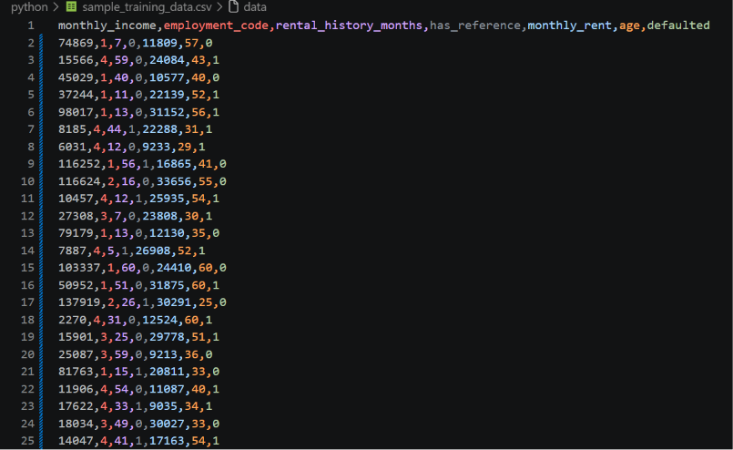
Landing Page
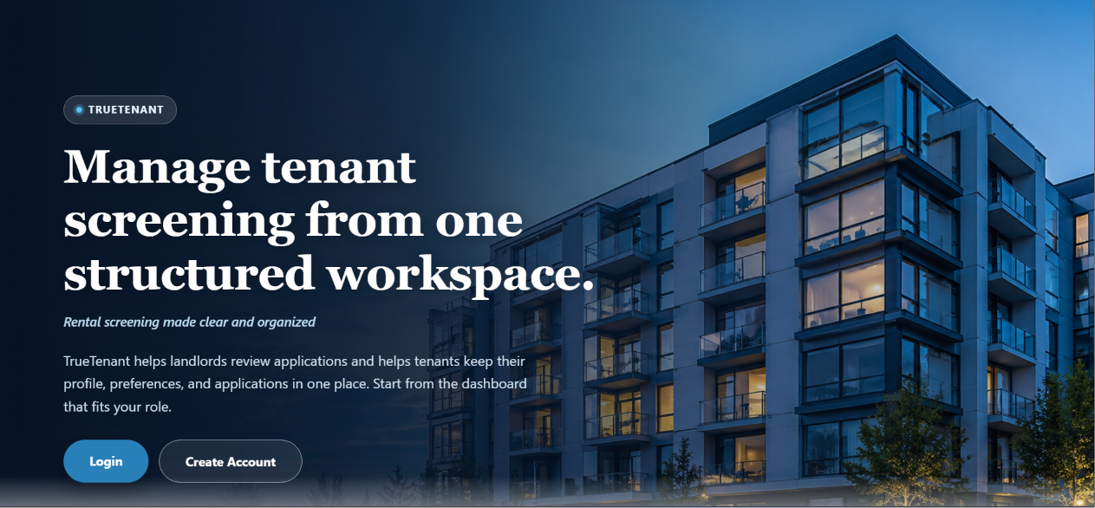

Login Page
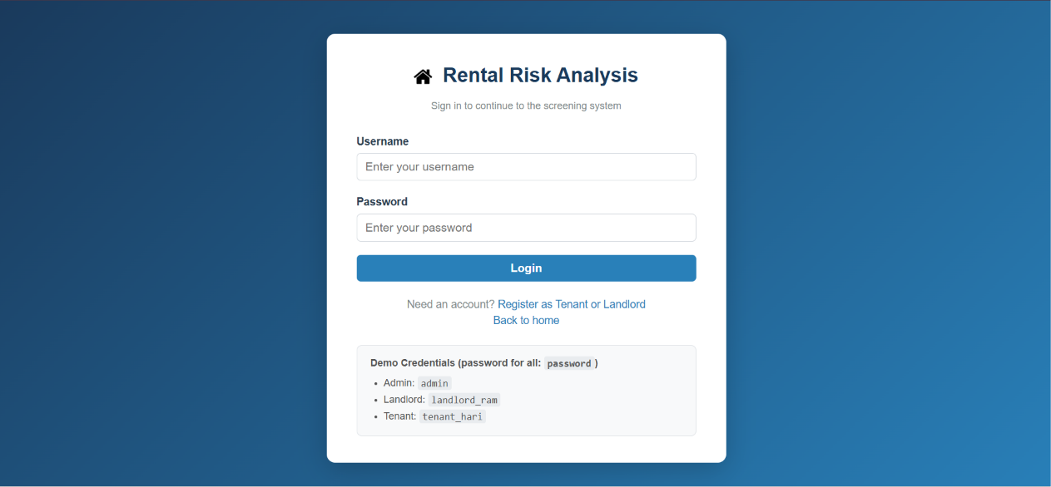
Signup Page
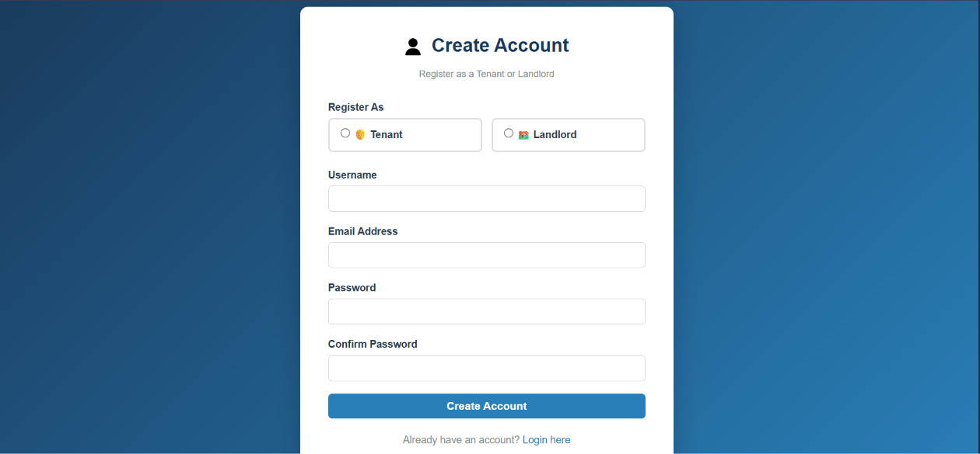

Tenant Dashboard
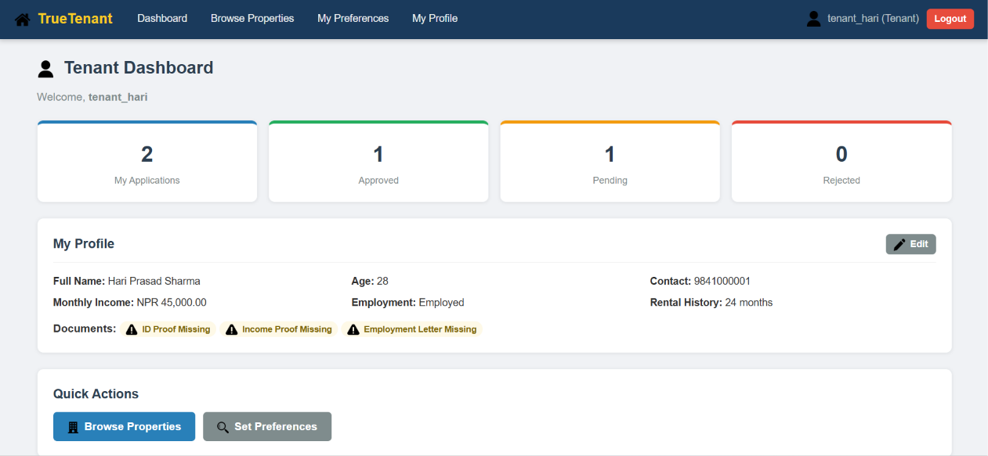
Tenant’s Application
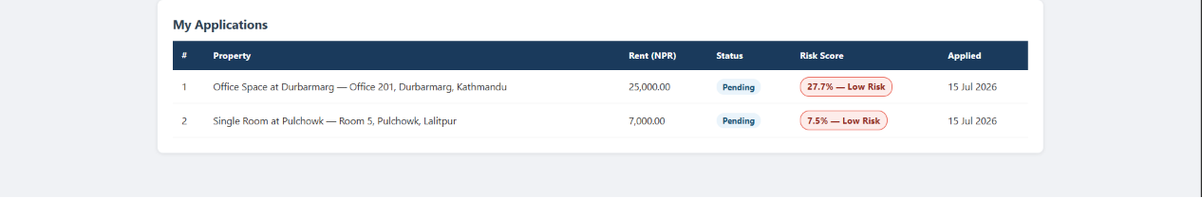
Browsing Properties (Tenant)
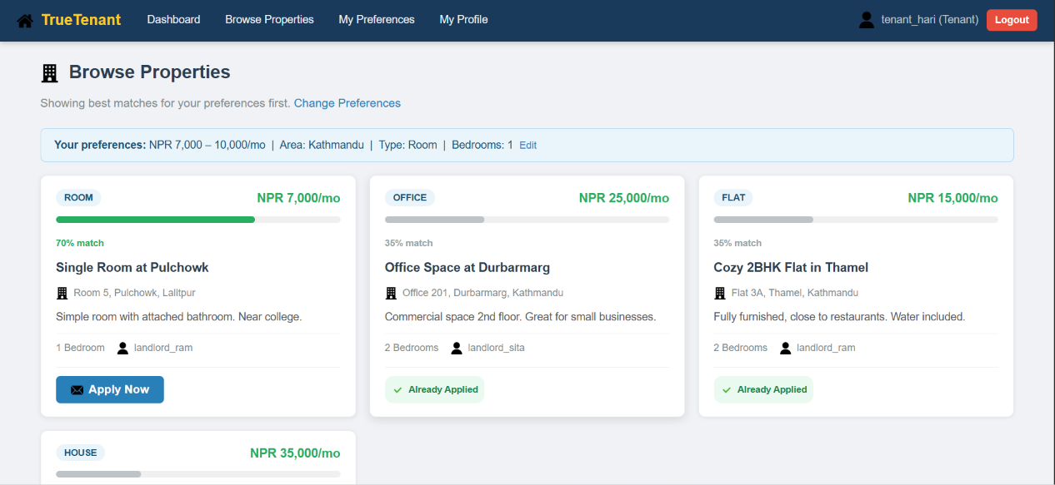

Tenant Setting Preferences
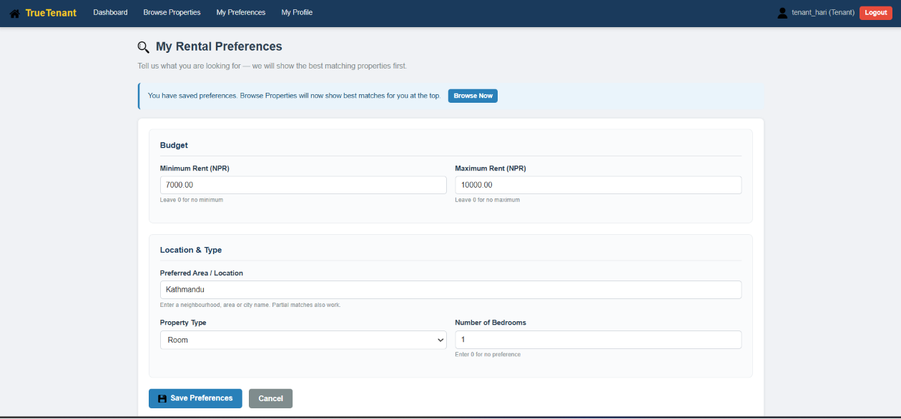

Landlord Dashboard
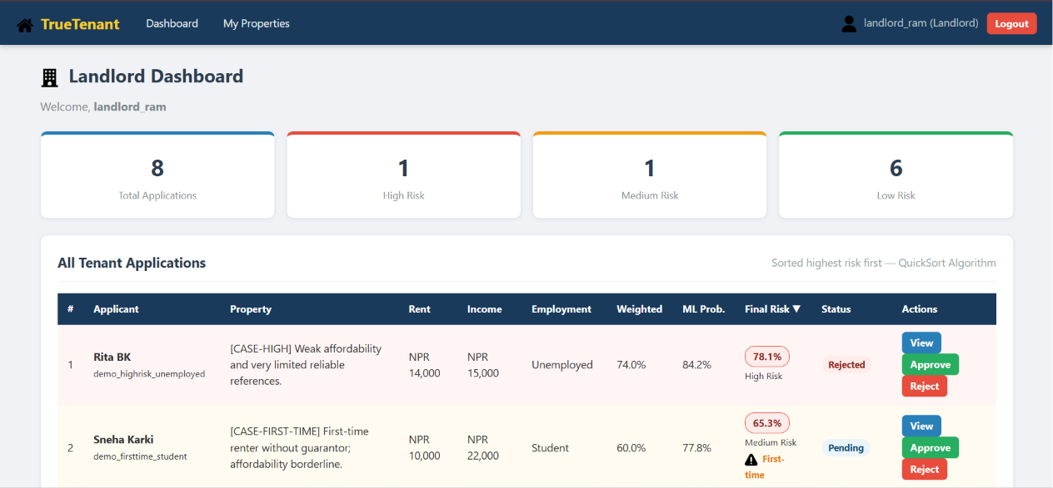

Landlord’s Properties
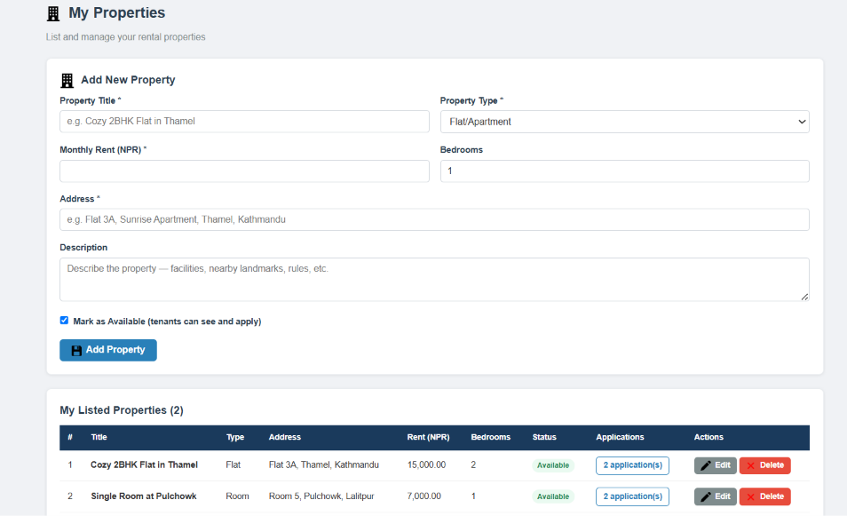

Landlord Viewing Applications
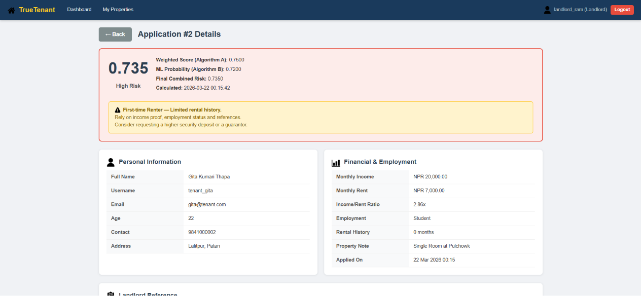

Admin Dashboard
